Big Bang Theory
Sheldon 1
Phase 1. Public speaking is very easy.

Description: (1) called function string is not equal
(2) pushed 0x080497C0

Phase 2. 1,2,6,24,120

Description: (1) read 6 #s.
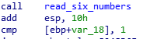
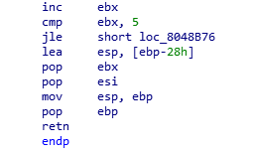
(2) a loop with iterations. ebx=1 ; ebx++ ; ebx<=5

(3) ebx=1;
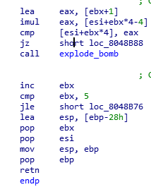
(4) eax= ebx+1; eax= eax*ebxeax
(iteration 0) I0: 1, I1: 2, I2: 6, I3: 24, I4: 120, I5: 720

Phase 3. 0 q 777

Description: (1) integer, character, integer
(2) the 1st # that’s been entered, should be less than 7 //a switch
(3) let’s choose 0 //1st integer (%d) is 0
(4) a second variable (b1) is equal to 71h assuming this should be a character (%c),71h~ q(ASCII) // 2nd character q
(5) compare the 2nd value to 309hthis should be an integer(%d), convert it to hexa,777 //2nd integer

Phase 4. ___

Description: (1) is an integer
(2) compare integer with 0, and if greater than 0 it gets pushed in to eax register & a “function 4” is called.
(3) the returned eax must be equal to 37h // 55 (decimal)

Phase 5. _____

Description: (1) calls a string length. //assumption it calls a string length
(2) eax =6? // string length of eax is 6
(3) pushes a string giants
(4) esi= string ‘isrveawhobpnutfg’
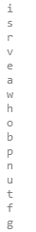
(5) our string is AND with 0xf // 0xf= 55 (decimal), can have multiple answers

Phase 6.
Description: (1) string has 6 #
Sheldon 2

